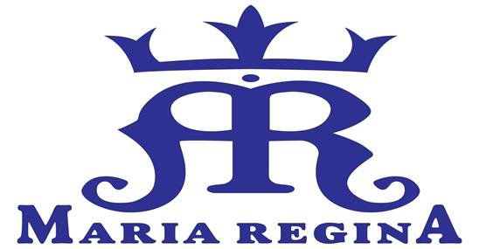 | Maria Regina Catholic Primary School  42 Central Road, Avalon NSW 2107  T: (02) 9918 2608  W: www.mradbb.catholic.edu.au  E: mra@dbb.catholic.edu.au

Kindergarten to Year 2

Internet and Network Services User Agreement 2020

Using the technology is a big responsibility and I am going to agree to be a good technology user.

When I use an I-pad, computer or chrome book
- I will have clean hands.
- I will use gentle hands.
- I will ask for help when I don’t know what to do.
- I will take turns with my classmates.
- I know that teachers might look at the work I am doing.

When I use the Internet
- I will tell my parents about the things I do on the Internet.
- I will stay on the web pages or Apps my teacher shows me.
- I won’t tell people on the Internet who I am or where I live.
- I will tell my teacher and my parents if I see something on the Internet that makes me feel uncomfortable.

If I don’t follow these rules then I will no longer be allowed to use technological devices.

Student’s name: ………………………………………………….…………………Class………………….….

Parent/Guardian’s signature: …………………….…………………..……… Date……………………..

